HEBEI UNIVERSITY OF ECONOMICS AND BUSINESS
THE UNIQUENESS OF XINJIANG
EDUCATIONAL TOUR ORGANISED BY INTERNATIONAL EDUCATION SCHOOL
BENJAMIN WIREDU BRITWUM
2015/10/24

1.0Introduction
Xinjiang was formerly known as Western Region, under the Han dynasty, which drove the XiongnuEmpire out of the region in 60 BCE in an effort to secure the profitable Silk Road
but was renamed Xinjiang which means "new frontier" the region was re-conquered by the Manchu-led Qing dynasty in 1759. Xinjiang is now a part of the People's Republic of China, having been so since its founding year of 1949.It became Autonomous region in 1955.Though I was fed with various degrees of negative perception about Xinjiang, I could not imagine bad perception can quickly turned into a good one, untilIembarked on an education activity in Xinjiang Uyghur AutonomousRegion. It is surprising such a unique region among the entire provinces in China is being classified as the unattractiveregion. A survey conducted shows that eight out of ten respondent express negative sentiment about Xinjiang.As Ibegan my thirty hours journey from Shijiazhuang in Hebei province to Urumqi which is the capital city of Xinjiang ,as a researcher and an investigator,I conducted a study in the train we used as a means of transport to Xinjiang.Theouctcome of the study shows that the instructor uses three different languages ;Chinese, Arabic and English. One will ask ,why the usage of Arabic language by the train instructor?The answer is very simple, majority of the population in Xinjiang are Uyghur’s whom are all Muslims.During lunch time ,I was very curious to know the food served in the train. As bold as I am ,I asked the waiter at the dining room whether he can serve me with Pork meat though I was a little bit scared to ask but my curiosity triggered me to order for pork.Fortunatly for me the waiter replied with a smile and said they do not serve Pork meat in a train to Xinjiang because majority of the people from Xinjiang do not eat Pork due to their belief.
2.0 Xinjiang’s Society
Urumqi which means beauty grassland is the capital city of Xinjiang.There are47 ethnicit-ies in the region.Some of these ethnicities are Uyghur,Han Chinese,Hui,Kazak,Kirgiz and Mongol etc. The majority ethnicity is Uyghur .It is very amazing Xinjiang shares a border with eight countries: India, Pakistan, Afghanistan, Tajikistan, Kyrgyzstan, Kazakhstan, Russia, and Mongolia. The low population of Xinjiang is one main factor that has helped the region attain the highest per capita GDP of any province outside the coastal areas.
In terms of administrative functions of the region, the people are being governed by a leader who is also an indigenous person because it is an autonomous region.
2.0.1 Religion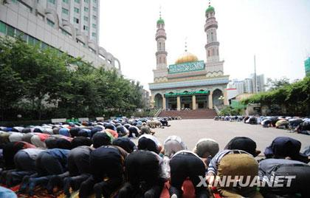
Although there are several religious activities practice at Xinjiang,example;Muslim,Christainity and Budhism.Muslim religion is mostly practice by the people.A Mosque can be easily located at different venues.While it is difficult for a Christian tourist to find a Cathedral or Church .
2.0.2 Food
Interestingly, the people of Xinjiang hardly eat rice. They are well known of eating livestock food, example; mutton, lamb and beef with a locally produce bread known as “Nan”. The rate of eating vegetables by the people of Xinjiang as compared to Chinese in other Province is very low. Most of the people prefer to eat more meat than vegetables. The most commonly fruit eaten by the people is grapes.
2.0.3 Timing
The people of Xinjiang are very unique to the extent that, their timing is different from the time other Chinese use. All Chinese and even foreigners residing within China have no option but to follow Beijing’s time but this is not the case of the people in Xinjiang. The Uyghur set their clocks and watches two hours behind the single official time zone in the rest of China.
2.0.4 Clothing
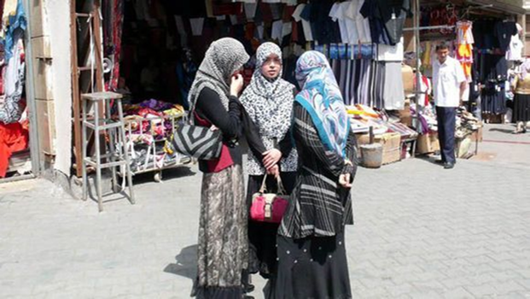According to Islamic teachings ,all Muslims especially the ladies are to cover their body from the head to toe and the men are also taught to cover the head.These Islamic teachings are well obeyed by the Uyghurs who are mostly Muslims.It has become part of their life.
2.0.5 Music
The local folks of Xinjiang have crafted their own source of musical instruments.These musical instruments produces unique sounds.
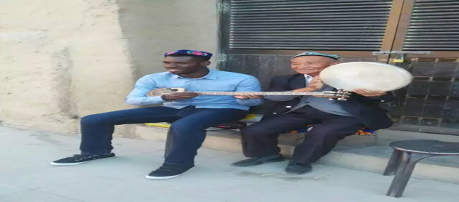
3.0 Weather
Xinxiang’s weather is different from other province weather.There are two Climatic Seasons in a year .The seasons are winter and summer .The Winter starts from October to April with a lowest temperature of -30 degrees Celsius.The summer starts from May to September with a highest temperature of +45 degree Celsius. The region experience longer nights and shorter days .This natural occurrences has affect the daily activities of the local folks.The people start work late in the day and close work early .Xinjiang cannot be describe without emphasizing that the hottest and driest part of China is located at one of the cities known as Turpan,which is located at the eastern part of Xinjiang.
4.0 Natural Resources
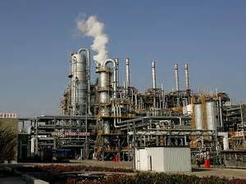The region is well endowed with abundance of natural resources. Example, Coal,Uranium,oil and natural gas. These minerals enable the region to generate revenue and serve as source of employments for the local folks and to a larger extent pull other Chinese from other province to Xinjiang in order to secure jobs.
5.0 Agriculture
Although large of the lands in Xinjiang are desert, there are availability of green vegetation that is conducive for cultivation of Cotton, pepper and grapes.The people of Xinjiang have the habit of rearing livestock excluding Pig.
6.0 Energy
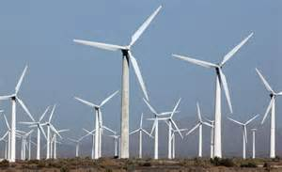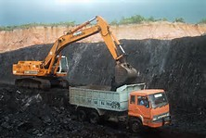There are three main sources of energy for the people of Xinjiang.The mainly sources of energy are Solar power ,coal energy and wind power.The people generate electricity from coal and sell the electricity to other provinces. This serves as a revenue for the region.
7.0 Tourism
Xinjiang has a lot of tourist sites which are well patronize by both Chinese and foreign tourist.Some of the notable tourist sites in Xinjiang are Flaming mountain in Turpancity ,the BaiZi Crick Thousand-Buddha cave scenic spot (Monkey King),Yar City which is the larges, oldest (2300 years) and best-preserved earthen city in the world with an area of 220,000 square meters.This tourist site was the home to 700 households, 6500 residents plus 865 soldiers.
Moreover,Karez Folk Garden is also a tourist site. The site depict the division of the city.It shows that the city is made of upper part,lower part and with green vegetation at the middle.It also have evidence of natural water originating from the mountain and underground water.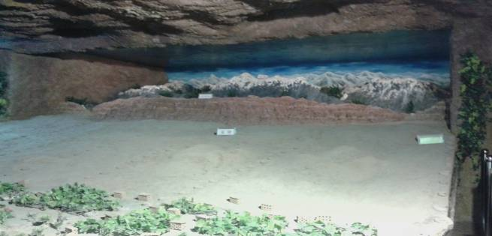
Again,we visited Turpan and Urumqi Museum .These two museums have preserved mummies and ancient valuables for several years. 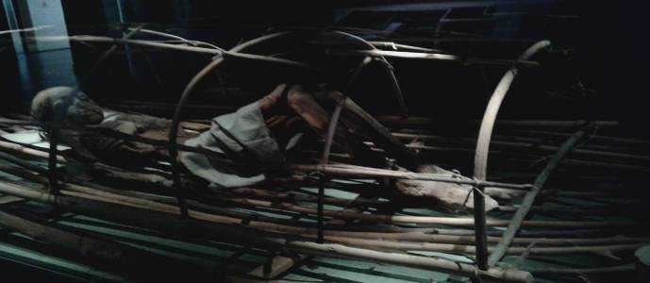
In addition we visited the heaven lake and heaven mountains.The heaven mountain and heaven lake is one of the best tourist site visited by most tourist who travels to Xinjiang.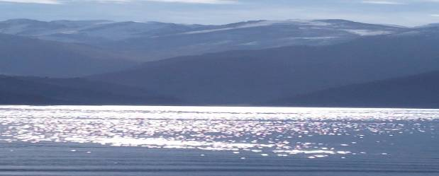Finally,we study the silk road which start from Shaanxi Province and passes through Gansu Province ,Southern Gansu,Hexi Corridor and Xinjiang Uygur autonomous region which goes further to middle east and finally to Europe.Foreign Merchants used the road as a means of transacting business with local folks. There is a Bazaar located at the center of Urumqi where a tourist can buy local products as dried fruits, local clothing, jewelry, music instruments, local foods and also foreign stuff as cosmetics and handbags.
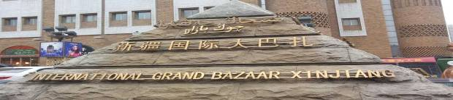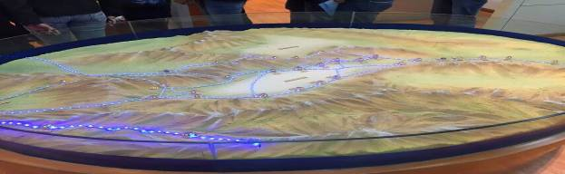
8.0 Security
From the writers perspective Urumqi is the Safest cityamong other cities in China.Any tourist in the region can testify that there are frequent Police and Military patrol ,various Police check points. Example, three thorough checking at train stations.Many detective machines at malls, bus stops, restaurant and hotels.
9.0 Mode of Instruction
The region is very unique in such a way that three different languages (Arabic, Chinese and English) as its mode of instruction.
10. Conclusion
From the study tour I had, I was able to determine that folks in a multicultural society must respect each other culture to generate a peaceful environment and enhance development. In addition, preservation of historical assets, culture, touristsites and finally making good use of natural resources also contributes to the growth of China’s GDP.

2

