SAHUI MAGBY HENRI JOEL REGIS
REPORT on XINJIANG SCHOOL TRIP

From October 14th to 19th , the International Education School of Hebei University of Economics and Business took us to Xinjiang Province. Here is the report on this trip.

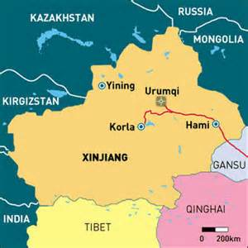
Map of Xinjiang

Xinjiang officially Xinjiang Uyghur Autonomous Region, is an autonomous region of China in the northwest of the country. It is the largest Chinese administrative division, the 8th largest country subdivision in the world. Its total area is 1,664,900 km² ,
its Capital and largest city is Urumqi, and its population is about 23 millions
Xinjiang contains China's smaller border with Russia, and Its other international borders are with Mongolia, Kazakhstan, Kyrgyzstan, Tajikistan, Afghanistan, Pakistan and India.
Xinjiang is also bordered, to the south, by Tibet, to the east, by Gansu and Qinghai provinces.
Xinjiang is home to a number of ethnic groups including the Uyghur, Han, Kazakhs, Tajiks, Hui, Kyrgyz and Mongols.
The main agriculture products are cotton, pepper, grape, and also livestock.
Also, in recent decades, abundant oil and mineral reserves have been found in Xinjiang, and it is currently China's largest natural gas-producing region

Xinjiang University
We went to Xinjiang University in order to attend a meeting with some foreign students.
We discovered the history of their school and also discussed about the silk road.
It was a nice moment for all of us to meet people from different area, living in Urumqi for a while. foreigners like us, talking to them, helped us to have a better understanding of Xinjiang.
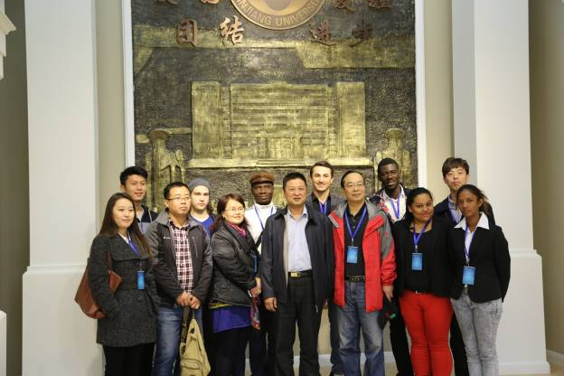
Xinjiang University hall
Silk Road
The Silk Road is a historically important international trade route and also cultural transmission routes between China and the Mediterranean. Because China silk comprised a large proportion of the trade along this ancient road, in 1877, it was named the 'Silk Road' by Ferdinand von Richthofen, an eminent German geographer.

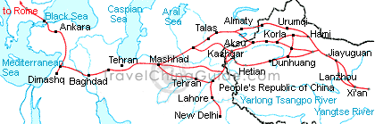
Map illustrating the Silk road

The silk road is now included in the World Heritage List of UNESCO. 33 historical sites are along the road in total and 22 of them distribute in Shaanxi, Henan, Gansu and Xinjiang of China.
Culture
The road is not only an ancient international trade route, but also a splendid cultural bridge liking the cultures of China, India, Persia, Arabia, Greek and Rome. The Four Great Inventions of China and religions of the West were introduced into their counterparts.
History
From the time Zhang Qian opened up the world-famous Silk Road during the Han Dynasty, until the collapse of the Yuan Dynasty, it enjoyed a history of about 1,600 years.
Route
This ancient road begins at Chang'an (now Xian), then by way of the Hexi Corridor, and it reaches Dunhuang, where it divides into three, the Southern Route, Central Route and Northern Route. The three routes spread all over the Xinjiang Uygur Autonomous Region, and then they extend as far as Pakistan, India and even Rome.
Other Routes
In fact, besides the Silk Road in the northwest of China, there are another two trade roads in the southwest of China and by sea, which also contributed greatly to the development of the world. They are called the "Southern Silk Road" and the "Silk Road on the Sea".
- Southern Silk Road
The southern route is mainly a single route running from China through northern India, the Turkestan–Khorasan region, Mesopotamia, and into Anatolia or north Africa.
The Southern Silk Road was mainly composed of West Route (Maoniu Route) and East Route (Wuchi Route). The West Route originated from Chengdu, wandered through Sichuan Province via Ya'an City, Maoniu (Hanyuan), Qiongdu (Xichang), and took traders to Myanmar (Burma) by way of Dali, Baoshan and Tengchong. Then its ancient trade route extended through to Juandu (India), Bangladesh and even Middle East. The East Route was very narrow and had only five-feet wide, so it was also called 'Wuchi Route'. It began from Chengdu, passed through Yibin, Zhaotong, Qujing and reached Kunming, where one branched road went to Vietnam and the other one wound to Dali, joining the West Route.

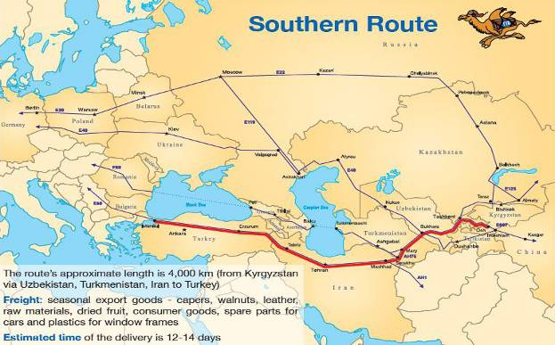
Southern Silk Road

- Silk road on the sea (Maritime Silk Road)
In order to distinguish it from the traditional Silk Road, this maritime trade route linking the East and West was given the name 'Silk Road on the Sea' by a Japanese scholar in 1967. The two most favored courses followed by trade ships were those of the East China and South China Sea Routes.
Guangzhou represented the starting-point of the South China Sea Route, which extended across the Indian Ocean and then on to various countries situated around the Persian Gulf. The types goods dispatched for trade consisted mainly of silk, china and tea, while imported merchandise included a variety of spices, flowers and grasses – hence it being commonly referred to as the sea's 'China Road' and the sea's 'Flavor Road' .

Grand Bazaar 大巴扎
We went to the Grand Bazaar to see some of the products sold through the silk road and we could notice the existing cultural diversity in Urumqi City.
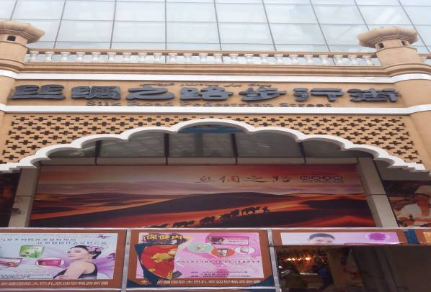
Entrance of Grand Bazaar 大巴扎
N 40 Middle School
We went to N40 Middle School which was our Dean’s former school to offer gifts to the students and make them happy. Because for most of them, it was the first time to talk to a foreigner. It was a pleasant moment and I really enjoyed it.

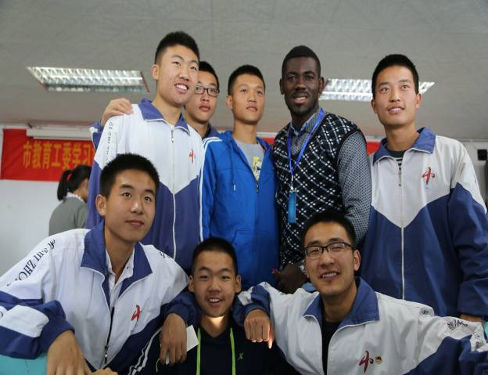
Picture with some N 40 Middle School students

Flaming Mountain
Flaming Mountain or Gaochang Mountains are barren, eroded, redsandstone hills in Tian Shan Mountain range, Xinjiang, China. They lie near the northern rim of the Taklamakan Desert and east of the city of Turpan. Their striking gullies and trenches caused by erosion of the red sandstone bedrock give the mountains a flaming appearance at certain times of the day.
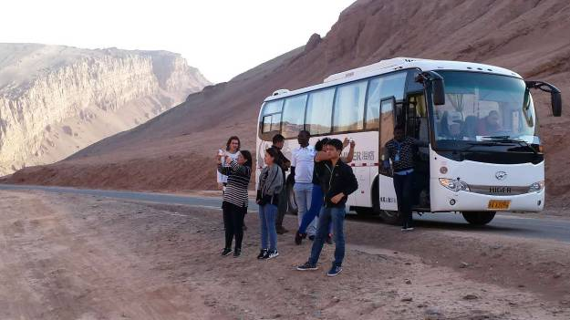
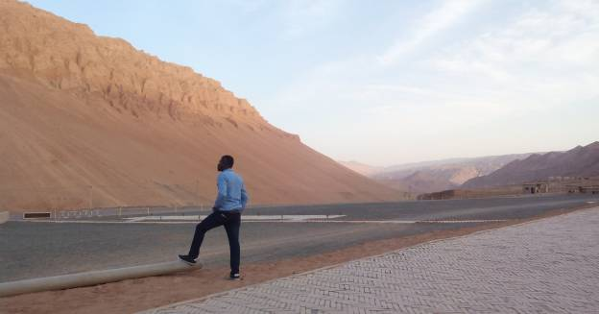
View of the flaming mountain
Bezeklik Thousand Buddha Caves

The Bezeklik Thousand Buddha Caves is a complex of Buddhist cave grottos dating from the 5th to 14th century between the cities of Turpan and Shanshan (Loulan) at the north-east of theTaklamakan Desert near the ancient ruins of Gaochang in the Mutou Valley, a gorge in the Flaming Mountains, China. They are high on the cliffs of the west Mutou Valley under the Flaming Mountains, and most of the surviving caves date from the West Uyghur kingdom around the 10th to 13th centuries

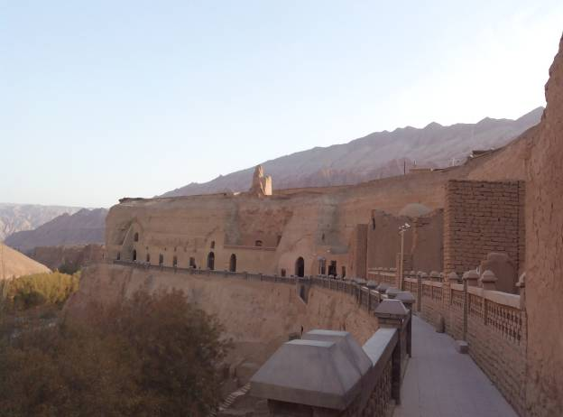
Bezeklik Thousand Buddha Caves

Site of Yar city
One of the world's architectural wonders hides in Yarnaz Valley. Like a willow leaf, the ancient city of Jiaohe (Yarkhoto) with a history of 2300 years lies between two rivers on a loess plateau atop a cliff of over 30 meters (98.4feet). The largest, oldest and best-preserved earthen city in the world, Jiaohe is 1,650 meters (5,413 feet) by 300 meters (984 feet) at its widest; with an area of 220,000 square meters (2,368,168 square feet). It was included in the World Heritage List on June 22, 2014.
A busy trading center, it was a stopping point for merchant traders traveling on the Silk Road. It was destroyed in wars during the 14th century, and old palace ruins and inside and outside cities can still be seen today. The ruins are located 30 km southeast of modern Turpan.

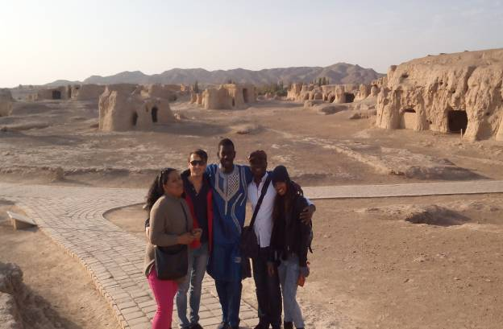
Picture at jiaohe site of Yar city

Karez irrigation system
We went to Turpan Water Museum dedicated to demonstrating its karez water system, as well as exhibiting other historical artifacts.
in Turpan, located in theTurpan Depression, Xinjiang, China, is a vertical tunnel system adapted by the Turpan people.
Turpan's well system was crucial in Turpan's development as an important oasis stopover on the ancient Silk Road skirting the barren and hostile Taklamakan Desert. Turpan owes its prosperity to the water provided by its karez well system
Karez systems are the crystallization of ancient people's diligence and intelligence. At its peak, this irrigation system exceeded 5,000 km (3,106 miles) and was also referred to as 'the underground Great Wall'
Karez systems are the life source of Turpan. In a sense, without them, there would be no Turpan culture.
Importance
Ample water was crucial to Turpan, so that the oasis city could service the many caravans on the Silk Route resting there near a route skirting the Taklamakan Desert. The caravans included merchant traders and missionaries with their armed escorts, animals including camels, sometimes numbering into the thousands, along with camel drivers, agents and other personnel, all of whom might stay for a week or more. The caravans needed pastures for their animals, resting facilities, trading bazaars for conducting business, and replenishment of food and water.
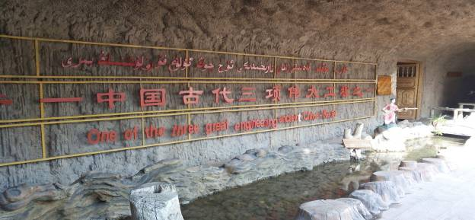
Entrance of the Turpan water Museum
Turpan Museum
Turpan Museum is regarded as the second largest museum in Xinjiang only after Xinjiang Regional Museum. Being on the route of the famous ‘Silk Road’, Turpan assembled traders and monks from western and eastern countries. Therefore, this place is left with abundant multi-cultural relics, which is also due to its special natural conditions: torrid, dry and rainless.
Main Exhibitions Halls
General History of the Turpan Area
This exhibition hall is mainly to show selected cultural relics that have been unearthed, levied, picked and donated since the founding of the People’s Republic. There were human traces in this area as early as the Stone Age. It entered the Bronze Age about three thousand years ago.

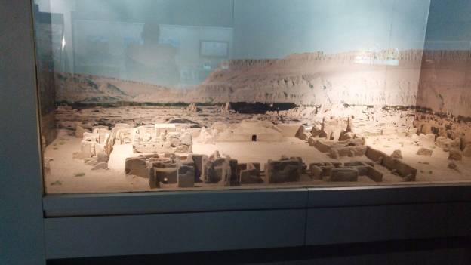

Giant Rhinoceros Fossil Exhibition
About 20 million years ago, the giant rhinoceros (Paraceratherium, also commonly known as Indricotherium or Paraceratherium), the largest land mammal ever known, lived in the area which was thought to be a sea, but dramatically to be a dessert now. It is said that it could eat about 500 kilograms (1,102 pounds) of leaves or grass every day. It is 5 meters (about 5 yards) high, and 9 meters (about 10 yards) long, with a weight of 30 tons (about 66,139 pounds). The fossil skeletons here are the most complete giant rhinoceros fossil ever excavated. Fossils of rhinoceros and other creatures in remote geologic ages are displayed with the aid of pictures, models, short films and videos, in order to give a vivid interpretation of the scene in millions of years ago.

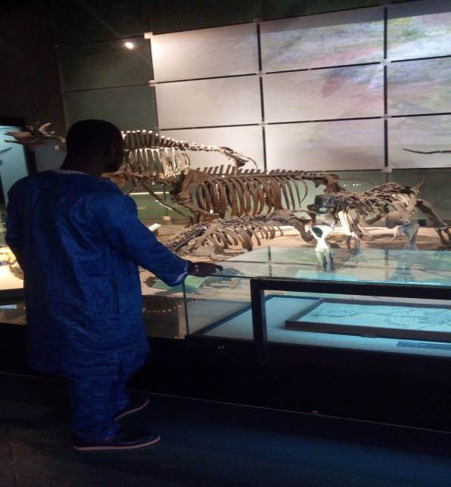
View of some Giant Rhinoceros Fossil
Ancient Mummy Exhibition
This is the most mysterious and attractive part of the museum. The mummies discovered in the area are bestowed by local geography and climate, like being dried by the Flaming Mountain.
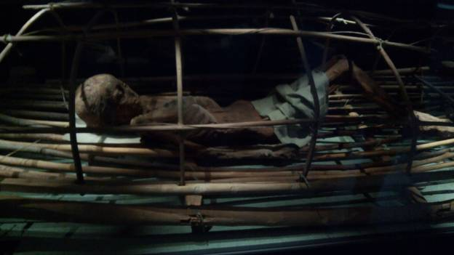
View of Ancient Mummy

Emin Minaret苏公塔
The Emin Minaret or Imin Ta stands by the Uyghur mosque located in Turfan, Xinjiang, China. At 44 meters (144 ft) it is the tallestminaret in China.^{[1]} The Qing Empire conquered this largely Muslim region in the 1750s by defeating the Dzungar Mongols with their superior weaponry in a series of battles. The Uyghurs under Emin Khoja joined the Qing Empire for protection against the Dzungars and the Emin minaret was named after Emin Khoja. As conquerors, they ruled the local population with a light hand and were tolerant of Islam
The minaret was started in 1777 during the reign of the Qianlong Emperor (r. 1735–1796) and was completed only one year later.^{[3]} It was financed by local leaders and built to honor the exploits of a local Turpan general, Emin Khoja, hence the name "Emin".^{[4]} The Emin Minaret is located along the ancient Silk Route (near the ancient Uyghur capital of Gaochang).
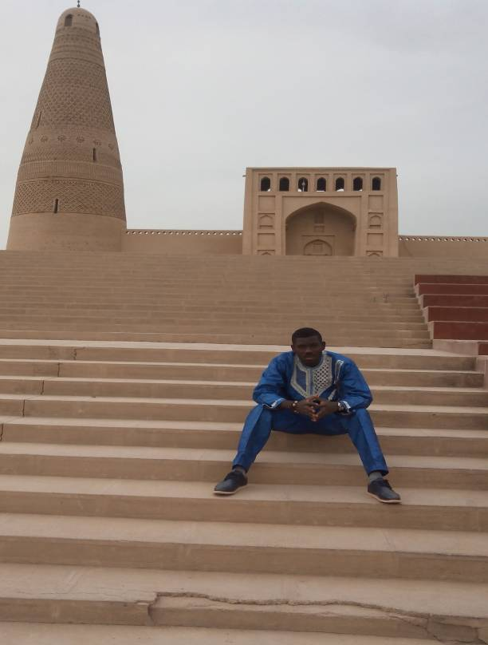
View of the Emin Minaret
Heavenly lake
Located in the middle of Northern Tianshan Mountains, 120 km (70miles) east of Urumqi, the Heavenly Lake stands 1910 m above sea level .It Covers 4.9 square kilometers, shaped like a crescent moon. It's a mountain moraine lake, surrounded by alpine meadows and rugged snow-capped mountains densely covered in fir, pine and cypress. The hills dotted with the Kazak yurts, the home of nomadic Kazaks.

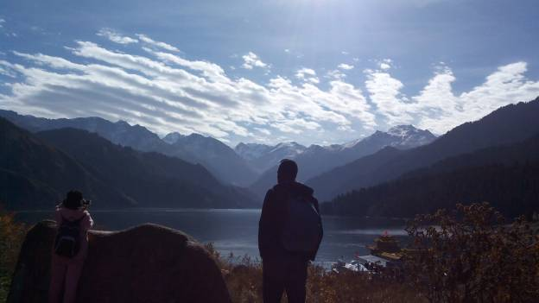
View of Heavenly lake

Urumqi Museum
Situated in Xibei Lu, in Urumqi City, the Xinjiang Regional Museum is a large integrated museum and centre for the collection and study of cultural relics discovered in the region.
The building is in a Uigur style, the internal decor having strong ethnic features.
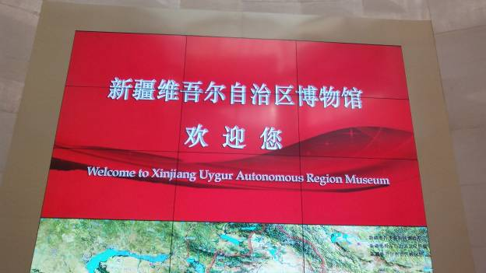
Entrance of Xinjiang Museum

In total there are over 50,000 items in the collection. These not only represent the ethnic lifestyle and humanity of the region
The exhibition relating to folk customs includes costumes, tools and every day necessities.
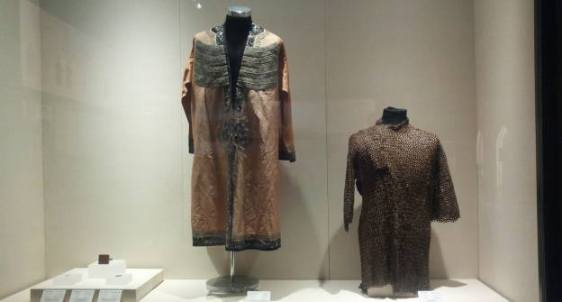
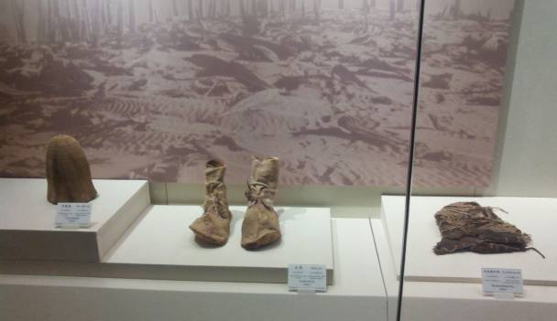

The historical relics include carpentries, ironwares, bronze wares, bright and beautiful brocades, tomb figures, pottery, coins, rubbings from stone inscriptions, and writings as well as weapons and so on.
The display of ancient corpses is fantastic, for it was in this region that a great number of ancient and well preserved remains were discovered. These are quite different from the mummies in Egypt that were created by skilled embalming procedures

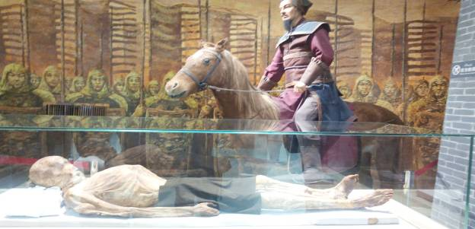
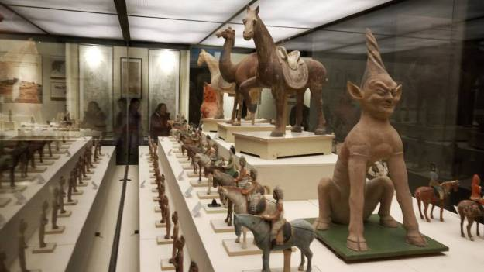

Conclusion
This trip in Xinjiang Province was very informative, because it showed us the existing cultural diversity on Chinese territory, in terms of food, religion, culture, living conditions. we could also have more knowledge about the Silk road, particularly on commodity exchanged and also the way of life of the people of this time.
We also discovered some unforgettable scenic spots, which will gave us a lot of satisfaction and pleasure.
I personally think that this trip in Xinjiang Province is one of the best trip, because I discovered unexpected places and got special feelings, although I travelled a lot around China. I would like to be grateful to my school and again say thanks to the organizers.

